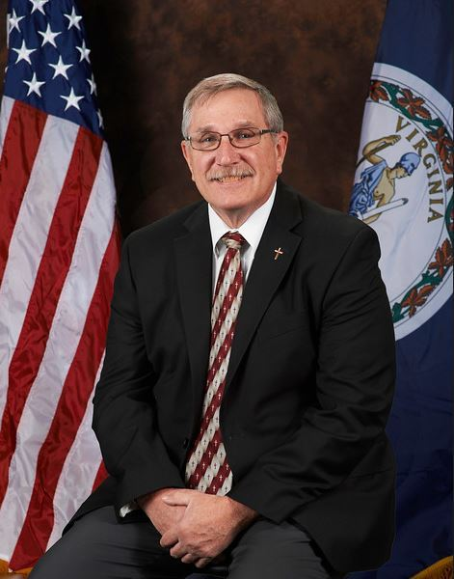
JAMES CITY COUNTY, Va. — Rev. David A. Daigneault, who served in law enforcement for more than three decades, passed away on Saturday, June 13.
The Massachusetts native and Army veteran began his career as a police officer with Williamsburg Police in 1975. From there, he worked as a deputy with James City County and spent many years in roles such as captain, major, and deputy chief.
In 2000, he became the police chief and served as such for five years before retiring. After retiring, he stayed in the law enforcement community by serving as the department’s accreditation manager for 15 years up until his passing.
Dave went on to become an ordained minister in The Wesleyan Church, serving in the Shenandoah District as an assistant pastor at both Christ Community Church and First Simple Church in Williamsburg, VA. He also served on the Shenandoah District Missions Board and thoroughly enjoyed his work in the ministry along with a number of mission trips to places like Guatemala, Cambodia, and Louisiana after Hurricane Katrina.
We all knew and loved Dave and those that knew him well know his faith put him at peace and comforted him until his passing. He is finally at peace and free of any pain and suffering. He will be greatly missed but his legacy lives on in all that knew him and for the impact, he made not just on the police department and community but in the lives of everyone he helped over his many years of service as an Officer, Chief, Pastor, Accreditation Manager, and overall incredible human being.
He is survived by his loving wife of 35 years, Bobbie, his daughter, Christina and son, Matt.
A private memorial service was held on Saturday, June 20th at Christ Community Church at 9001 Richmond Rd. Toano, VA.

