

**Launch Proposal**

**Steve and Courtney Hubbard**

Table of Content

**Proposal Overview 3**

**Grand Ledge 4**

Location Overview 4

Demographics 4

Area Assets and Opportunities 5

Spiritual Need 6

Ministry Implications 6

**Statements of Identity 7**

Our Name 7

Our Mission 7

Our Vision 7

Our Strategy 7

Core Values 8

**Personal Information 9**

Meet My Family 9

Our Call to Plant 9

Spiritual Gifts and StrengthsFinder 10

**Timeline and Next Steps 11**

Next Steps 11

Launch Timeline Overview 12

Timeline Phases 12

**Launching Budget 13**

**Thank You For Consideration 14**



Proposal Overview

**CALL TO PLANT**

We are presenting our call to plant a church that multiplies disciples, leaders, and churches. We believe God is calling us to launch a new work in Michigan that reaches the unchurched, dechurched, and far from God.

**LOCATION**

We believe God has called us to begin a new work in the West Lansing Region in the city of Grand Ledge. This historical city is hungry for a fresh expression of the Gospel and is an ideal location for a work of church multiplication. Grand Ledge is less than 3 miles from the larger community of Delta, and houses the school system. Together, these communities reperesent nearly 40,000 people and 18000 homes.

**STEVE AND COURTNEY HUBBARD**

My name is Steve Hubbard. I am an ordained minister in the Wesleyan Church in Indiana North. My wife, Courtney and I have been married 8 years and have three children. Together we are seeking God’s confirmation and calling through this proposal.

**TIMELINE**

We see God continuing to open doors as we network with people and churches. We see ourselves serving as a resident pastor through the Greenhouse Network through the remainder of 2015 followed by the prelaunch phase headed towards a fall 2016 launch.

Grand Ledge, MI

**Location Overview**

Grand Ledge, Michigan is located just west of Lansing and houses the school system to neighboring community, Delta. There are 31000 people in the Grand Ledge school district. She is a bedroom community to Delta and Lansing. It is an incredibly historical city that builds its life around sports, performing arts, outdoors, and more. Grand Ledge has grown to its capacity in its city limits, however, Delta is growing towards it at an incredible rate. There is a lot of vitality in business, schools, and recreation.

**Demographics**

When talking about Grand Ledge, we must also take into consideration certain demographics regarding Delta. The two cities are growing closer and closer together.

Delta and Grand Ledge are 3 miles from one another. (Grand Ledge School District includes Delta, while Delta holds major commerce)

Basic Demographics

* + 1. 7800 – Population (Delta – 32000 Population)
    2. 5300 students in school district (Delta included in Grand Ledge School District -31000 people in school district)
    3. Population Break-Down
       1. Grand Ledge
          1. 3357 households
          2. 75% Households were family units

32% Households w/kids

43% Households w/married couples

3 People - Average Family Size

* + - * 1. 38yrs – Median Age

24%< Age 18

34% Ages 19-44

27% Ages 45-64

15% > 65

* + - 1. Delta (Growth of 9% between 2000-2010. 13% between 90-00)
         1. 14200 households
         2. 60% Households were family units

16% Households w/kids

46% Households w/married couples

2.8 People - Average Family Size

**Demographics Contd.**

* + - * 1. 38yrs – Median Age

24%< Age 18

31% Ages 19-44

29% Ages 45-64

16% > 65

* + 1. Income Levels
       1. Grand Ledge
          1. Median Household Income Level - $52000
          2. Average Household Income - $63000
          3. Per Capita Income Level - $26000
       2. Delta (per 2000 census)
          1. Median Household Income Level - $52700
          2. Average Household Income - $65400
          3. Per Capita Income Level - $27000
    2. Racial Makeup
       1. Grand Ledge: 92.4% White, 7.6% Black/Asian
       2. Delta: 76.8% White, 11.6% Black, 11.6% Other
    3. Religious Statistics for ZIP 48873
       1. +14% growth in past 10yrs
       2. Grand Ledge
          1. 65% not affiliated with a church
          2. 35% Religious affiliation

15% Protestant

14% Pentecostal

6% Catholic

**Area Assets and Opportunities**

Grand Ledge is rich in heritage and opportunities.

* Grand Ledge is incredibly historical.
  + - * 2nd lighted city in the state
      * 1880’s City boomed, many buildings still exist
      * 1880’s first roller coaster in state
    - War reenactment every spring
* Choice School District – Cutting Edge Education
  + - * 31000 people in school district. Economically diverse
      * Though a bedroom community of Delta/Lansing, houses the school system for majority of students west of lansing.
* Life around Ledges
  + - * Rock Climbing, state parks
* Diversity Index
  + - * Grand Ledge and Delta are primarily white. Delta being the more diverse at 25% minorities.
* Population density (2100 per sq. mile)
  + - * Delta is growing towards Grand Ledge as a result

**Spiritual Need**

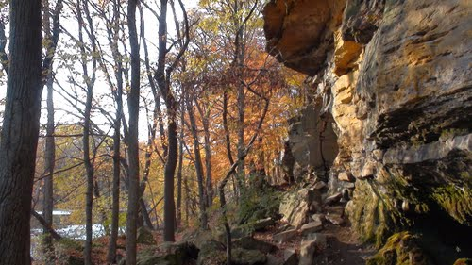While the school system is cutting edge and the area is thriving, the spiritual opportunity continues to grow. The growing percentage of religious affiliation is misleading as the statistic is derived from the county. Locally, Grand Ledge does not have any leading churches paving the way for people to connect with the Gospel.

The area is hungry for a fresh expression of the Gospel. There is a lot of pride in Grand Ledge….but all the cutting edge ministries are outside of its city walls. If a church were to come in and spark the imaginations of its people, real headway could be made.

With 75% of households being family units and 32% of them having kids, there is a real opportunity to reach our target audience: Young families and marriages. These families will probably be under the age of 45 initially. This includes 75% of households and 55% of population.

**Ministry Implications**

Our church needs to scream we love kids AND the family. It needs to be in our verbage, our atmosphere, our décor…etc. We cannot cut corners as we will be competing with the local school system that is highly resourced.

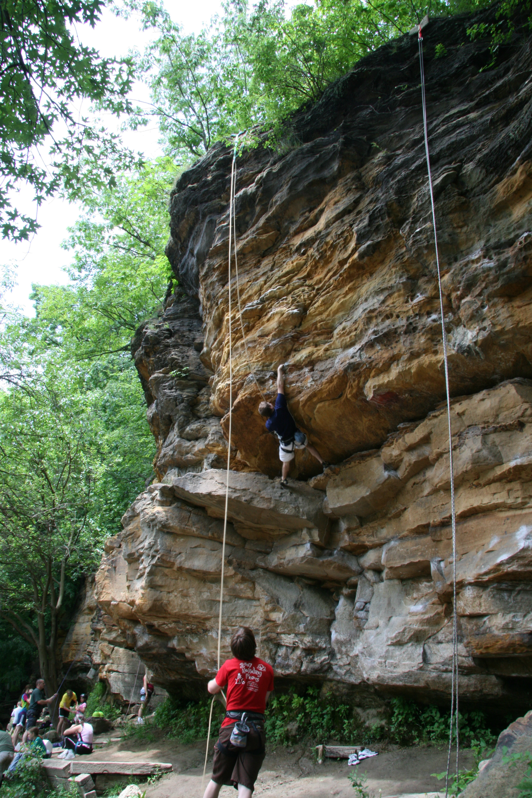Our programming needs to be “home” based. Discipleship happens 24/7…so we need to resource the home. (Homes with kids or not)

We need to be relevant but also aware of the tradition of the city. Grand Ledge is cutting edge but is incredibly historical. The “Ancient-New” descriptor comes to mind. Our atmosphere needs to have a revamped, relevant take on tradition.

Multiplication needs to be talked about in every ministry. Multiply disciples, leaders, and churches. Delta is closing in on Grand Ledge. The two areas already share a school district. The surrounding area is growing, so our church needs to as well.

We need to talk about Delta in everything…Delta is becoming increasingly relevant. All their kids come to Grand Ledge. All sporting events are held here. We need to embrace the surrounding communities. (This also cultivates a culture of church multiplication)

Statements of Identity

**Our Name**

Awaken Church is a community of people who believe that an encounter with God awakens us to new life. Whenever we experience new life, we are awakened to new freedom, new purpose, and new love. Our heartbeat is to see the un-churched, de-churched, and far from God experience new life.

*“Up on your feet! Take a deep breath! Maybe there’s life in you yet. But I wouldn’t know it by looking at your busywork; nothing of God’s work has been completed. Your condition is desperate. Think of the gift you once had in your hands, the Message you heard with your ears—grasp it again and turn back to God.*

*“If you pull the covers back over your head and sleep on, oblivious to God, I’ll return when you least expect it, break into your life like a thief in the night.*

*“Conquerors will march in the victory parade, their names indelible in the Book of Life. I’ll lead them up and present them by name to my Father and his Angels.*

*“Are your ears awake? Listen. Listen to the Wind Words, the Spirit blowing through the churches.” - Revelation 3:2-6 MSG*

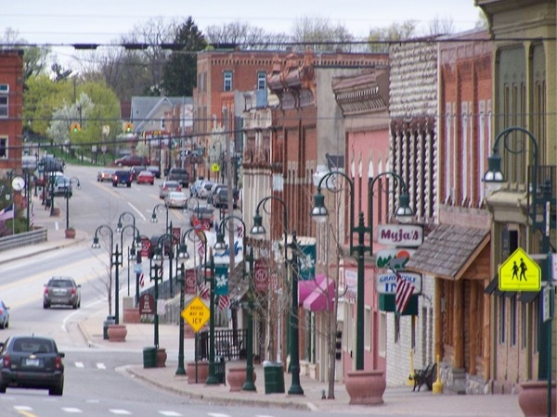**Our Mission**

*“…Make disciples of all nations, baptizing them in the name of the Father and of the Son and of the Holy Spirit, and teaching them to obey everything I have commanded you.”*

*-Matthew 28:19-20.*

Awaken Church exists to see the Great Commission realized in people, families, and communities.

**Our Vision**

Awaken Church will multiply and mobilize passionate Christ-followers to *BE* the hands and feet of Christ awakening the world to new freedom, purpose, and life.

**Our Strategy**

Awaken Church accomplishes our vision through three focuses:

**-The Home-**

We empower marriages, families, and homes to be a disciple making house church. Our schedule, ministries, and resources serve to strengthen the home.

**-The Church-**

We evangelize in order to disciple. We disciple in order to evangelize.We mobilize disciples to worship and serve on Sunday gatherings, develop personal ministry and mission, live life in small groups, and serve in local outreach.

**-Church Multiplication-**

We multiply leaders and churches through church planting and building people. We will multiply our vision and mission by investing in the Kingdom Movement.

**Core Values**

The following values are foundational to our culture and how we answer the question: *“How will we pursue executing our mission and vision?”*

**Simplicity Permits Focus**

We are pursuing one vision and focus our energies and resources around it. We defend ministry simplicity so we can focus on accomplishing our mission.

**Real People Really Love**

We all are broken people seeking to love God together…despite our brokenness. We are authentic in living life together. Authenticity grants grace.

**Multiplication is Our DNA**

We multiply believers, leaders, and churches. Expect to grow and go.

**Numbers are Stories**

We care about numbers. Each number is a person. Each person has a story. Every story matters to God.

**We are Generous**

We give faithfully and generously. Our team and church will give generously to the work of God in our church and community both with our finances and our lives.

**Family First**

The first church is the home. We will equip homes to be spiritual strongholds and places for spiritual connectedness. Our church will not burden the family, but unite them in purpose, vision, and mission.

**We Dream Forward**

We will never arrive. We need to consistently and intentionally re-invent ourselves to meet the spiritual needs of the areas we live the Gospel.

**“Imagine If” Culture Counts**

Imagination leads to transformation. We need to spark peoples imaginations and invite them into a shared experience and culture.



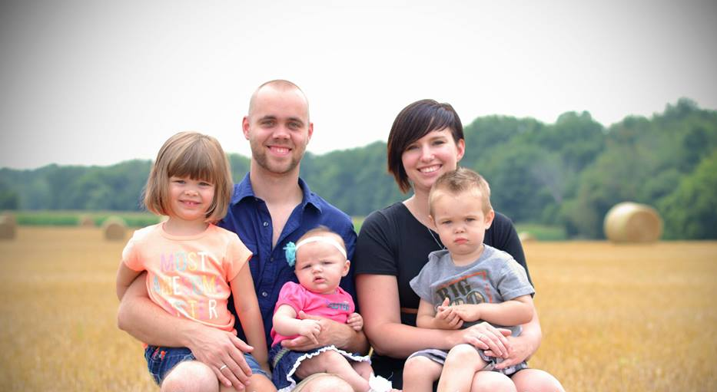Personal Info

**Meet My Family**

Courtney and I grew up just north of Grand Rapids Michigan in the small communities of Grant and Newaygo. We met in high school and were married at the age of 19. We came together convinced that God would transform us and use us at a greater capacity together than we could ever be on our own. We have been married nearly 9 years and now have three kids: Natalie (5), Isaiah (3), and Faith (1).

Courtney is a stay at home mom and we anticipate this continuing until the kids are in school. We both value this season of life as being an opportunity to build up our children with the values and tools to enter the world. Courtney has an incredible heart and soul. She is the bravest individual that I know. She fearlessly enters into new chapters of life leaning into faith. She was not raised in a Christian home, and faith is something that had to be learned in her adult years. I admire her.

Our children are full of life, challenges, and energy! We love them. Natalie begins school this coming fall. She is incredibly compassionate and we are excited to see God continue shaping her heart. Isaiah is a gear head. He loves building things up, taking them apart, and figuring out problems. He is the ham of the family. Faith is our youngest addition that completes our family. She is learning to walk and discover her role as the “youngest”.

**Our Call to Plant**

David Platt’s words in *Radical* resonate with me,

“*Do we really believe He (Jesus) is worth abandoning everything for? Do you and I really believe that Jesus is so good, so satisfying, and so rewarding that we will leave* ***all we have*** *and* ***all we own*** *and* ***all we are*** *in order to find our fullness in Him? Do you and I believe Him enough to obey him and to follow him wherever he leads…?"*

3 Years ago, I felt God stirring in my heart to begin pursuing a call to plant a new church. As I prayed, I felt God say, “Yes, Plant, just not yet.” I began exploring this call and helped a new church build a foundation for launch. Prior to the move, I still felt God saying “Wait”. We stayed behind and I remained on staff at Fairmount Wesleyan Church as the Family Pastor where I oversaw many of the ministries and team development.

This past year has been spent seeking God’s direction for my life. Courtney and I really began engaging in our local church and saw fruit of our labor. We developed great relationships with the staff, community, and larger church family.

**Our Call to Plant Contd.**

During this season of life, God began to stir in my soul. I began to feel the weight and responsibility for the number of lost families in Michigan. The weight of responsibility became so heavy that I began actually asking God to clarify his call on my life…and for my family.

I immediately spoke with my senior pastor, my prayer partners, and my spouse so we could discern together how God is leading. I enrolled in Wesley Seminary’s Church Planting program and went through the Church Planting Assessment Center. I believe God speaks through the church and those in leadership. In working with Ed Love, the Assessment Center, and with my prayer partners, God has made it incredibly clear that his heart is longing to impact families and homes in Lansing Michigan…and he is calling Courtney and I to abandon comfort and security for the purpose of growing his Kingdom. He is calling us to find fulfillment in his mission and his love.

**Spiritual Gifts and StrengthsFinder**

I began working at a young age in our family business. Through high school and college I ran my own branch of the business and found entrepreneurial efforts highly engaging. I had to discover my leadership strengths and deficits. I’ve been able to further discover who I am through ministry experience. I am currently a “Ministries Pastor” and help oversee the building and development of teams. Here is a snapshot of my spiritual gifts.

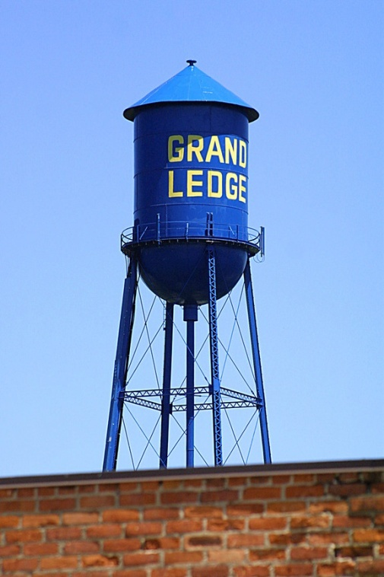Clifton Strengthsfinder 2.0

1. **Connectedness**  - Looking at the big picture and letting it guide life and leadership.
2. **Achiever** – Benchmarks and goals as motivation and driving engine.
3. **Ideation** – Fascination with new ideas, opportunities, and possibilities. Broad understanding of connecting people and concepts.
4. **Command** – Leading with confidence
5. **Competition** - Competitive atmosphere as motivation.

Spiritual Gifts Inventory

1. **Administration** – Bringing continuity in people around tasks, vision, and mission.
2. **Leadership** – Leading people to fit together, grow as individuals, and accomplish tasks.
3. **Wisdom** – Letting truth inform and guide decisions and leadership.
4. **Exhortation** – Building people up with words of encouragement and challenge.
5. **Pastor/Faith** – Shepherding people to love God and each other. Posturing our life to lean on Christ.

|  |
| --- |
|  |
|  |
|  |

Timeline and Next Steps

**Next Steps**

In preparing to launch a new church in 2016, we anticipate taking the following next steps to prepare our family, team, and church for a healthy launch.

1. **Season of Transition**

Empowering ministry at Fairmount Wesleyan to self-sustain. Moving to Grand Ledge, MI. Complete Church Planting Certificate.

1. **Season of Development – Church Planting Residency**

Work with the Greenhouse Network and Ed Love to gain experience in church planting. Begin Church Planting Residency at The Well, Ionia and other network churches. Areas to develop:

* **Speaking/Teaching** – July 5th-August 2 Preaching at The Well, Ionia
* **Discipleship/Evangelism Methodology** – Engaging new converts in discipleship and ministry mobilization. Creating evangelistic culture.
* **Developing Church Plant Culture** – Finding practical steps to engaging new people, protecting mission, and developing culture.
* **Ministry Partnership** – Networking and building relationships with The Well, Epic, The Bridge, and other Greenhouse Network Churches.

1. **Season of Discovery**

Discovering and connecting with Grand Ledge. Engaging with the school system. Volunteering at community events. Build relationships with community. Learn the culture, values, and shakers of Grand Ledge.

1. **Season of Preparation**

Begin developing ministry partnerships, resources, and training networks.

* Exponential – April
* IMAP with Chris Conrad
* Bootcamp
* Fund Raising/Prayer Partners

1. **Season of Launching**

Building Launch strategy, timelines, and teams. Grow ministry partnerships.

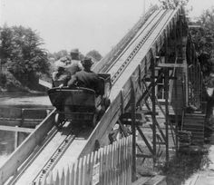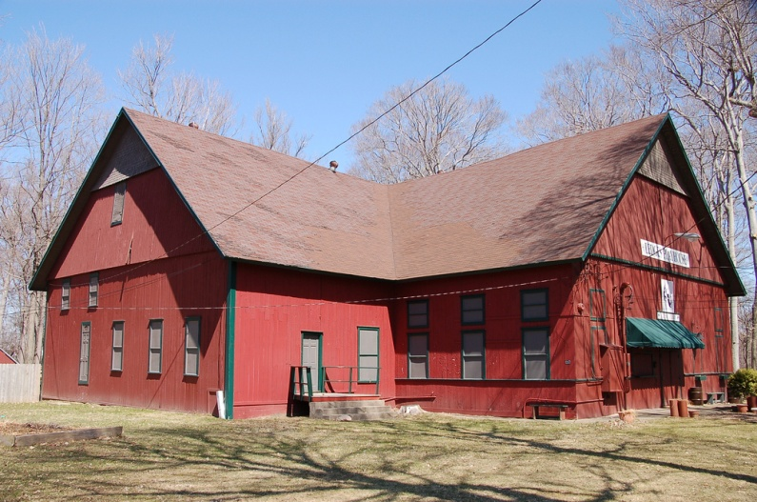

**Fitzgerald Park – Built in 1800’s for Seances First Roller Coaster in Michigan**

**Now used as youth playhouse.**

**Launch Timline - Overview**

Awaken Church is seeking to launch weekly gatherings beginning in September 2016. Here is the outline of our anticipated timeline.

1. Move to Grand Ledge, MI. June 2015
2. Develop Ministry Partnerships Beginning June-December 2015
   1. Residency – Resident Pastor
   2. Greenhouse Network
   3. Fund Raising
   4. Initial Launch Team Membership Development
3. Launch Team Life Groups Begin January 2016
   1. Meets Bi-Weekly 1st and 3rd week
      1. Meeting 1 – Prayer, Spiritual Gathering
      2. Meeting 2 – Strategic Gathering: Strategy Development
      3. Build Launch Team
4. Launch Team Initiatives April-July 2016
   1. Visit other Church Plants in Greenhouse Network
   2. Ministry Partnerships in community
   3. Build Launch Team
5. Preview Services August-September 2016
   1. 3 Preview Services: Bi-Weekly until Launch
6. Launch Weekly Gatherings Mid-September 2016

**Timeline Phases**

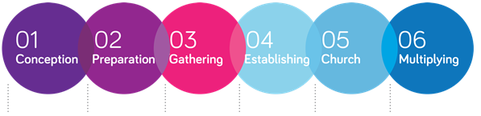

Discover call and core values. Discern where God is leading and dream.

01

Move to area. Meet people. Network with ministry partners. Begin residency.

02

Gather in life groups. Build launch team. Grow leadership

03

Engage

Community

Promotion and local outreach efforts. Develop identity.

04

Launch preview then weekly services. Mobilize disciples to evangelize

05

Multiply leadership ministries, and churches. Strategize new plant locations.

06

Launching Budget

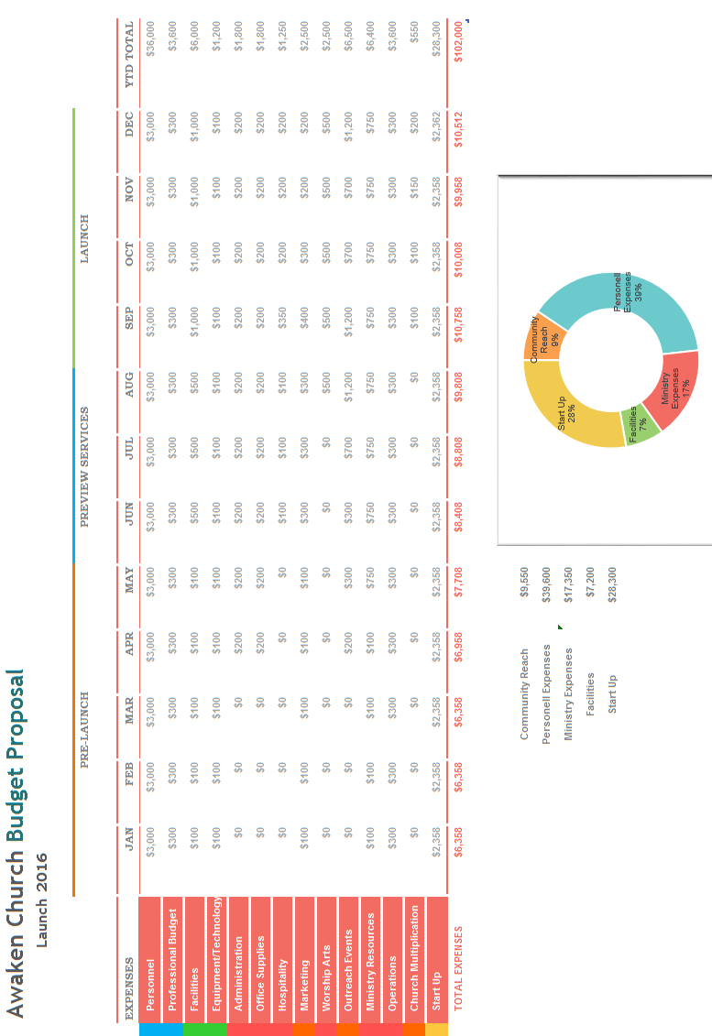

Thank You For Consideration

Thank you for allowing me to paint a picture of what God has been working in our hearts to do. Grand Ledge is full of opportunity and spiritual hunger. There are families needing a fresh expression of the Gospel. There are people living their lives who need the hope and life that Christ offers. Christ is building his Church. Courtney and I just want to be part of that. We want to be available for this great work in this great city.

Could I ask you to consider partnering and empowering this new work?

The West Michigan District has a great track record of networking church planters together for missional success. The DNA and culture that is being produced in this territory is winning lives and souls for the Kingdom. Courtney and I would like to ask that you consider allowing us to join your team and network. As we prepare our hearts and souls for this adventure, we would ask you to consider partnering with us in the following ways.

1. **Affirmation of Call** – Your guiding hand of approval and sending will further affirm that God is indeed calling us to this territory. Your commissioning us to go and pioneer a new work in Grand Ledge would be significant!
2. **Financial Empowering** – A financial partnership with the West Michigan District would mean receiving valuable resources for a healthy launch. We are looking to begin our major financial partnerships beginning in January 2016 in preparation for a September launch.
3. **Prayer and Networking** – I am continuing to prepare my heart, soul, and mind for this new endeavor. Your prayer and networking are invaluable in this season of preparation.

Thanks again for your time and consideration. I look forward to connecting soon!

Sincerely,



Stephen Hubbard

livexfaith@gmail.com

260-573-6447