Prompts to Guide the Evaluation of your Discipleship Model

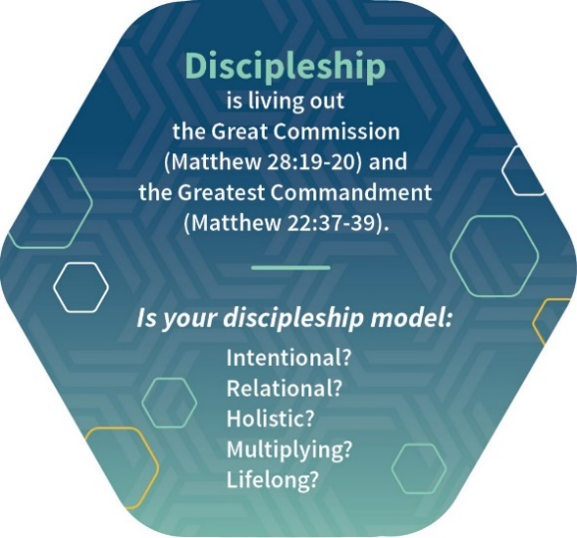

Intentional: A clear and contextualized process nurturing the cycle of Believe, Belong, Become.

Relational: Values all three types of relationships in Matthew 22:37-39—with God, with ourselves and with others.

Holistic: A comprehensive Christ-like lifestyle transcending a church-dependent program and leading to a transformed life, church and community (James 1:22, John 13:17).

Multiplying: Reproducing believers, leaders and churches.

Lifelong: A continual process of spiritual growth which requires more than a curriculum, catechism or multi-step process.
______________________________________________________________________________

You can download a printable file of this card by clicking here.

For hard copies, please email Stephana Bledsoe with your request.
We will mail as many as you would like!

